Last name:  First name:  Date of birth:  Marital status:  Residence:  Phone:  E-mail: | Plesca  Maria  17.01.1985  married  Chisinau, Nicolae Dimo Street No.5/1 apt. 53  GSM +373- 690-70-280,  maria.plesca.tgm@gmail.com | 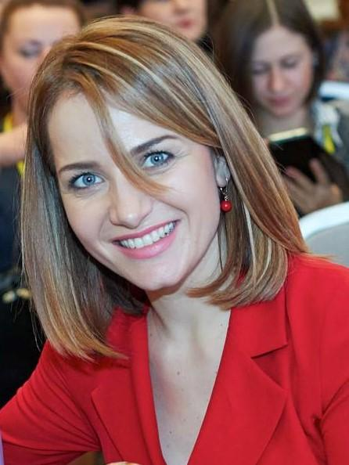
Education: | 1.HIGH SCHOOL „LUCIAN BLAGA” Chisinau city  2. BACCALAUREATE DIPLOMA at the High School of the National College of Commerce under the Academy of Economic Studies  3. ACCOUNTING COURSES (for obtaining professional qualification, specialization: Accounting - duration 7 months)  4. THE AGRARIAN STATE UNIVERSITY OF THE REPUBLIC OF MOLDOVA  Faculty : Accounting  Specialty: Accounting | 2002-2004  October – June 2005  2004-2009
Professional experience: | 1. S.A. „Echipament” the company activity - lease of premises for offices and warehouses, position – cashier-accountant  2. S.R.L. „TINGRIMAR” , the company activity - trade of industrial goods, manufacture of special clothing (specialized shop), initially I held the position of Chief Accountant, at the moment I hold the position of Manager  3. S.R.L „Elgario” Chief Accountant, I’ve been worked in the provision of foreign language services and translations.  4. Non-governmental Organization "ACASA", the activity of the Charity and Social Assistance Association - position Accountant, but I  have also fulfilled the duties of Chief Accountant.  5. Notary Public Office – accountancy of the professional activity.  6. S.R.L. „Petricomert” the company activity - the provision of transport services and construction materials sale, position - Chief Accountant  7. I have fulfilled other auxiliary duties all over these years: Secretariat, Personnel Department and other.  Ongoing professional retraining  8. JSC „Ecofin Consult” - I have been trained in the ongoing training program in the field of accounting with respect to "National Standards of Accounting" in force as of 01.01.2014 with Marcela Dima  9. Audit Company "International Evidence" LLC. I have been trained in the ongoing training program in the field of accounting with respect to " National Standards of Accounting" in force as of 01.01.2014 with Marcela Dima  Certificate No. 040 dated 03.12.2014 | February – September 2006  October 2006 – till present  January - June 2008  September 2009-April 2011  January 2012- till present  January 2013 -  July 2013  November 25, 201 3 - December 11, 2013  December 01, 2014  – December 03, 2014
 | 10. II „ Rotaru Valentina” Auditing and Consulting Company  Experts / Assistant Accountant in Professional Audit Activity.  11. JSC „Finantari MD” - Training courses "Expert in accessing non-reimbursable funds"  12. Bussines Training Centre „AHP International” GmbH & Co. KG Program for the managers skills training within the project GIZ Germany and the Chamber of Commerce and Industry of Moldova  (Manager Training Program of the German Federal Ministry for Economic Affairs and Energy with Moldova)  13. Course of ongoing professional training “Training of Manufacturing Masters-Instructors for Moldovan companies" with a length of 300 hours (10 credits ECTS) obtaining the position - "Manufacturing Master-Instructor", code CORM 23925 as of 08-09 December 2016  14. Training session for the examiners in dual education GIZ Moldova within the Project Structural Reform in Technical Vocational Education in the Republic of Moldova.  15. Program for the Moldova-Austria managers skills training within the Project WKO WIFI Austria and the Chamber of Commerce and Industry of Moldova.  16. Program of Entrepreneurial Development within the Project "Business Academy for Women" ODIMM (48 academic hours)  17. The professional training program "Entrepreneurial Competences" organized by the Excelsior Association for Excellence in Education within the project "Entrepreneurial Diaspora" contract POCU / 89 / 3.7 / 107604  18. Trainer within the GEA / ODIMM project in collaboration with the Chamber of Commerce and Industry  19. Participant in the training program EU Project "Support for Quality Infrastructure in the DCFTA Context in the Republic of Moldova" within the Chamber of Commerce and Industry of the Republic of Moldova  20. Ministry of Education, Culture and Research National Institute of Economic Research (INCE) function - Scientific researcher, 0.5, external  Entrepreneurship Research Section  Carrying out scientific research within the SP Project "Multidimensional evaluation and development of the entrepreneurial ecosystem at national and regional level in order to boost the SME sector in the Republic of Moldova" in order to multidimensional assessment of the entrepreneurial ecosystem in the Republic of Moldova.  21. Participant in the training in the field of Financial Management, the first ACAP module with CAP / CIPA certification | March 01, 2016-  till present  August 11, 2016  May 30– June 24 2016  in Germany  July 22– December 02, 2016  April 3-6, 2017  October 9-13, 2017  October 20 –  2 November, 2017  Iune – iuly 2018  11-27 november 2019  December 2019 – June 2020  January 2020- till present  15 september- 15 october 2020
Foreign languages: | SPANISH – at the conversation level, ROMANIAN – mother tongue, RUSSIAN, FRENCH, ENGLISH- I'm studying at present.
PC knowledge: | 1C – Accunting, MS OFFICE - Word, Excel, Internet Explorer,
Purposes: | I am interested not to disappoint your expectations and confidence, for a continuous professional development and the value of skills and abilities that I have gained over the years to lead to remarkable results during our co-operation.
Other information: | FLEXIBLE, ORIENTATED TO A RESULT,  Abilities of PROBLEM SOLVING;  WISH TO gain more KNOWLEDGE AND EXPERIENCE IN DIFFERENT FIELDS;  LABOR AVAILABILITY AND LABOR FORCE within A NORMAL AND AN AUXILIARY WORK PROGRAM;  ORGANIZATION AND COMMUNICATION ABILITIES;  - RESPONSIBILITY, LOGIC THINKING, ANALYTICAL ABILITIES, DILIGENCE AND perseverance;
Hobby: | Attendance: swimming pool, instrumental music, concerts, theater, psychological literature and fiction, attending foreign language courses and other.

